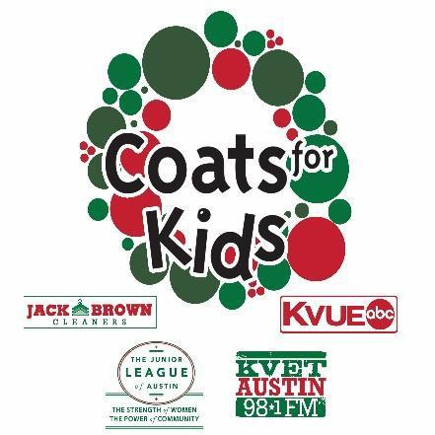
2017 Coats for Kids
Distribution Day

Saturday, December 9, 8:00 a.m. - 3:00 p.m.

Palmer Events Center, 900 Barton Springs Road

Coats for Kids, now in its 31st year, is an annual community event that collects and distributes new and gently worn winter coats to the eligible youth of Central Texas.
To receive a coat, a child must be 18 years of age or younger and must show proof of both age
and income. The lists below include acceptable forms of proof.
One of the following  PROOF OF AGE | AND | One of the following  PROOF OF INCOME
Government Issued ID cards  Birth Certificate  CHIP Card  School ID with picture  Medical/Immunization record |  | Current Pay Stub  Enrollment in free/reduced lunch program  WIC Card  CHIP Card  Medicaid Card  MAP Card  Lonestar Debit Card  SSI (Social Security Income) Card
**Parents or guardians without children present on Distribution Day must show both (1) proof of child’s age and
(2) proof of income (limit 6 coats per household).

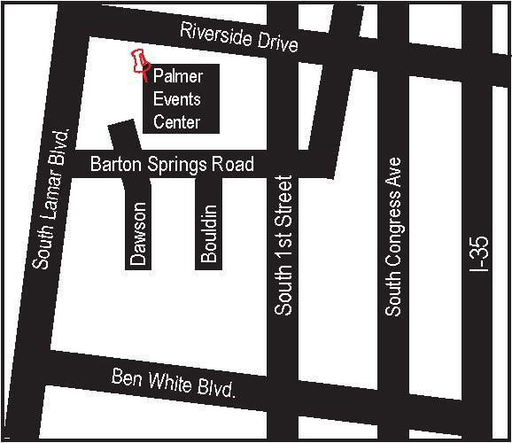

For More Information:
Phone: (512) 467-8982
Email: cfkcoats@jlaustin.org
Website: www.jlaustin.org/coats

From IH-35, go west on Riverside Drive. Turn left on Barton Springs Road. The Palmer Parking Garage is on your right. Complimentary parking is available beginning at 6:00 AM. Palmer Events Center is to the west of the parking garage.

The front entrance is on Barton Springs Road.

The Palmer Events Center is served directly by bus routes 5, 10, 110 & 30. The 1, 3, 7, 20, 801, 803, and 338 routes also serve near the Palmer Events Center.*

*Please see capmetro.org/planner or call 512-474-1200 for updated bus routes and schedules.

After you receive your coat, please visit the
Coats for Kids Warm Bodies
Healthy Hearts Community Fair
located outside Palmer Events Center!

Approval of distribution of these materials is in no way an endorsement of such services, activities, and/or products by the distributing of Austin Independent School District.

